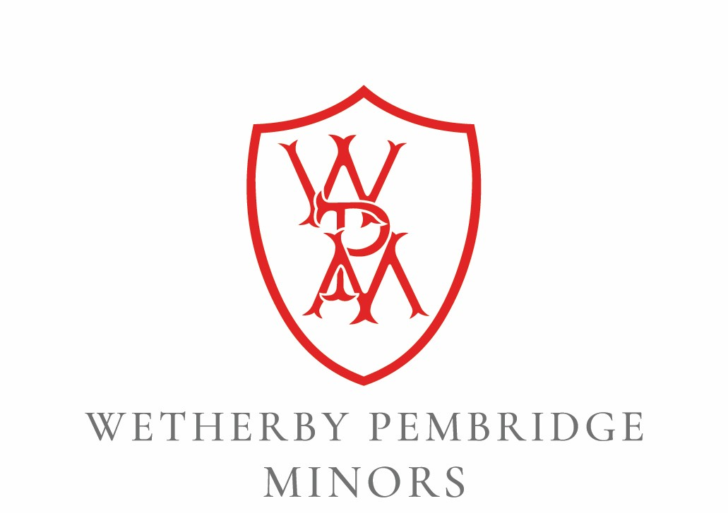

English as an Additional Language (EAL) Policy

Policy reviewed by: Sam Edwards
Review date: June 2024
Policy actioned from: September 2024
Next review date: June 2025
Reviewer’s Signature:

Headteacher’s Signature:

Circulation: This policy has been adopted by the governors, is addressed to all members of staff and volunteers, is available to parents on request. It applies wherever staff or volunteers are working with pupils.
Please note: ‘School’ refers to The Minors Nursery School; ‘parents’ refers to parents, guardians and carers.

Purpose of the policy:
To ensure that we support children with English as an Additional Language (EAL) and adopt practices that enable them to effectively learn to understand and communicate in English.

Responsible Persons: Senior Leadership Team and Staff Team

Definition

At Wetherby Pembridge Minors (hereafter ‘WPM’), we welcome children and families with EAL and we recognise all will have their own, individual experiences and backgrounds. For the purpose of this document, we will use EAL as an umbrella term that encompasses all levels of English acquisition and any child learning and using English as an additional language.

Statement of Intent
Our intention is to provide support children with English as an Additional Language (EAL) and adopt practices that enable them to effectively learn to understand and communicate in English. We understand that children will start at WPM with differing levels of fluency in English and partnership with parents is vitally important to a child’s progress. We communicate with parents about how we will support their child, how they can support their child and valuable it is to continue speaking their first language/s. We value the child’s home and school languages equally.
There is an important distinction to be made between having EAL and having a Special Educational Need or Disability (SEND). Children will not be classed as having SEND because they have EAL, though we do recognise that some children may have both SEND and EAL and will be supported in accordance with their own individual needs and interests.
All children should have equal access to a broad, balanced curriculum and be given the opportunity to communicate in any first language, as it has a continuing and significant role in identity, learning and acquisition of further language development.
We promote equal opportunities and anti-discriminatory practices; differences are celebrated and any resulting needs are addressed; further information with regards to this can be found in our Equal Opportunities & Inclusion Policy.

Aims and Objectives

- To welcome the cultural and linguistic experiences of every child and ensure that we meet their full range of needs as effectively as possible.

- To maintain a child’s self-esteem by acknowledging and celebrating their individual culture and skill in their first language/s.

- To implement strategies and monitor children’s progress to ensure that they are supported to access the complete curriculum.

- To support children with EAL to understand and communicate in English, and to develop their confidence in doing so.

To support the above aims, staff members must:

- Gather and share information about the child’s background (including but not limited to the language/s the child speaks, religious and cultural customs followed by the family and any dietary requirements).

- Ensure that parents know that we value, welcome and celebrate different languages and cultures.

- Establish consistent, simple, daily routines, checking that the child understands what to do and, wherever necessary, helping the child with their understanding on a one-to-one basis.

- Provide consistent visual aids (pictures and objects) for children with EAL to support their understanding.

- Consistently use gesture and tone of voice to aid understanding and language development.

- Acknowledge children’s attempts to communicate regardless of whether they are in English, a home language or non verbal.

- Model appropriate, correct language and grammar at all times, using lots of repetition and ensuring that interactions are positive.

- Identify opportunities to teach and embed targeted vocabulary and key language structures and ensure that these are included when formulating planning for the individual child, the child’s key group and whole class planning.

- Plan for the consistent and meaningful inclusion of children with EAL in small group activities in order to enable frequent meaningful episodes of interaction with peers, through activities which promote communication.

- Acknowledge that children with EAL may go through a ‘silent period’ or ‘quiet period’ before they feel confident to try communicating in English. Acknowledge that they may not want to use their home language at school

- Consistently model language. Provide a running commentary / talk through actions.

- Treat non verbal responses from children with EAL as valid turns in conversation and model a corresponsing verbal response for them. Paraphrase and extend one-word and short responses are to longer sentences to model increasingly complex language, as appropriate.

- Recognise the important role of parents and strive to maintain effective partnerships with parents and carers to ensure every possible element of support is provided.

When children join the school, we use our ‘language mapping’ form and other initial parent forms (such as a personalized list of high frequency words in the child’s home language/s) are used to help further inform us about the child’s abilities in their home language/s and how best to support them.

Each child will be supported in line with the EYFS and extra support implemented as needed depending on the individual needs and interests of the child.

Individualised and ongoing monitoring and support will be in place as needed, incorporating, as much as is possible, the support of the parents.

